**Model Evaluation using Visualization**

**TOTAL POINTS 2**

1.Question 1

Consider the following **Residual Plot**, is our linear model correct :

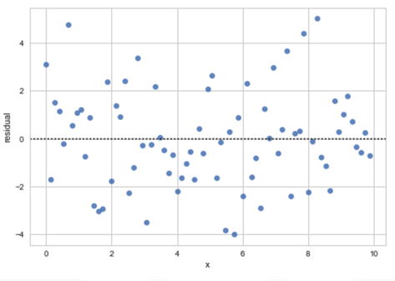



yes



incorrect

1 point

2.Question 2

Consider the following **Residual Plot**, is our linear model correct :

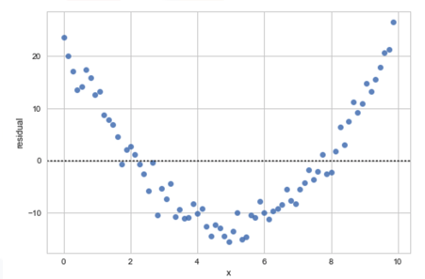



yes



no

1 point